
Nemo Office Club Preparing for a Positive 2024 and beyond

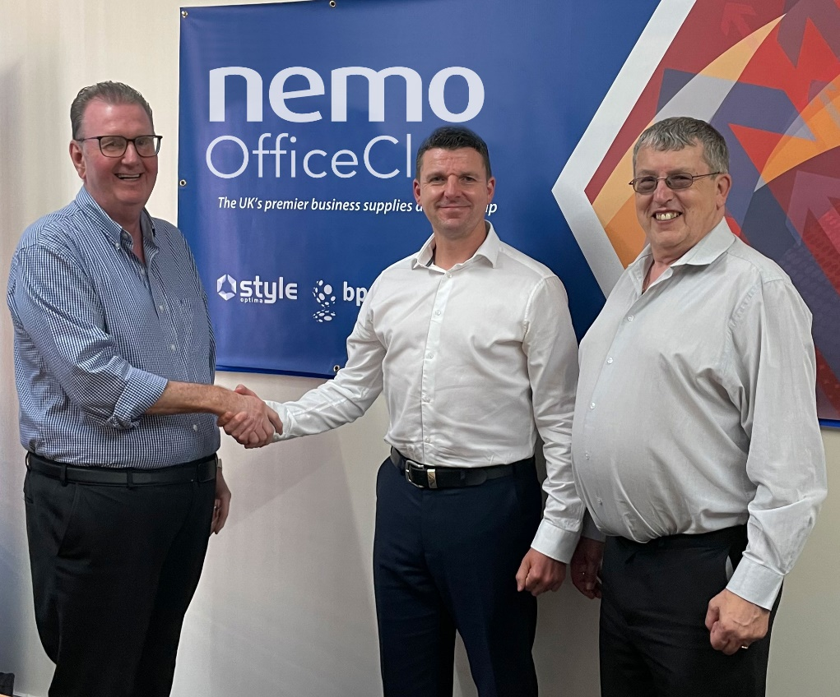
Atherstone, Warwickshire, June 2023: Dealer group Nemo Office Club has renewed its deal and partnership with Vow Wholesale providing members with ongoing support and opportunities through aligned sales and marketing strategies as they prepare the ground for a positive 2024.
“These remain challenging times for dealers,” explains Nemo Office Club Managing Director, Tim Beaumont, “and it is important that our members are able to access the broadest range of product categories, both existing and new, to supply their customers in a reliable and competitive manner. Vow clearly understand that requirement and I am delighted that we share a vision that has led to this new deal and extension to the relationship that will help our members to grow their sales and improve profitability.”
(L-R) Tim Beaumont, Nemo Office Club MD; Darren Renshaw, Dealer Development Director, Vow and Derek Bamford, FD,Nemo Office Club renew strategic partnership.
As plans develop for 2024 Nemo Office Club will again be producing a uniquely coded catalogue with cross-referencing to allow dealers to choose their best source of supply throughout the life of the publication. As Tim explains: “We have always been about giving dealers choice and have tailored our marketing in that way. Dealers are not committed to one source of supply and have the flexibility to react to their own unique circumstances - be that location, size or product mix, as well as being resilient to changing markets without impacting on their customers or their ordering process.”
Tim Beaumont confirmed that Nemo Office Club is in the process of laying the foundations for 2024 with the catalogue having a major makeover and further supply partner announcements on the way. “We are very optimistic that our members have positive times ahead. We have invested in expert design consultants to maximise the impact of the printed catalogue for them with their customers and we have a number of very exciting new and renewed supplier partnerships to be announced shortly. Watch this space!”

FOR IMMEDIATE RELEASE

Contact: Alan Calder, Marketing Manager, 01923 947036 / Email: alan.calder@nemoofficeclub.co.uk

